CHEMICAL KINETICS I. THE BASIC IDEAS.
RATE CONSTANTS AND ORDER OF REACTION
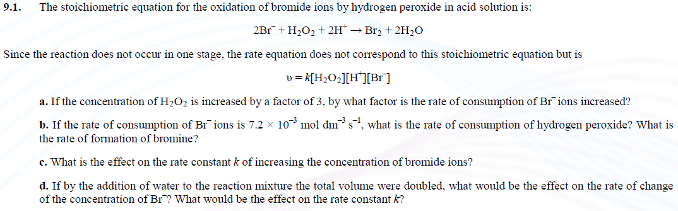
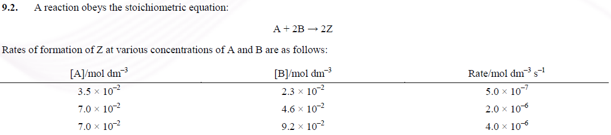
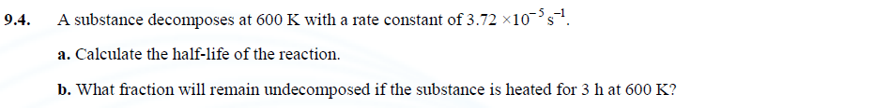
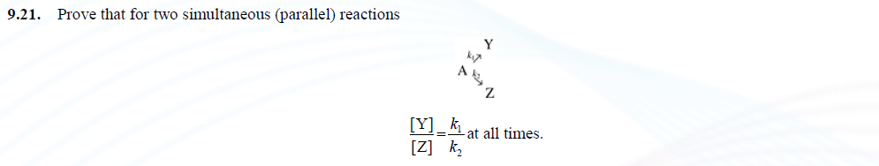
TEMPERATURE DEPENDENCE
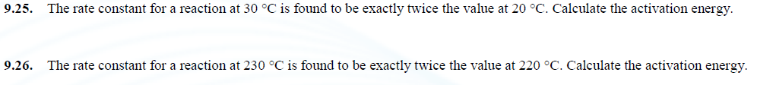
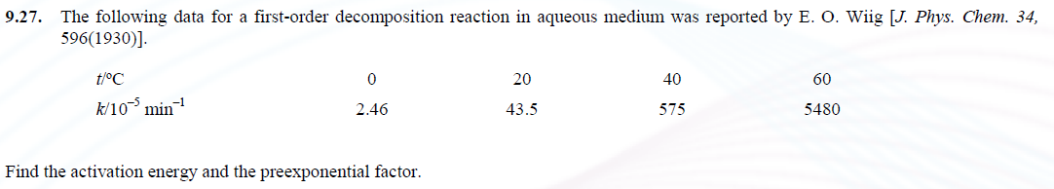
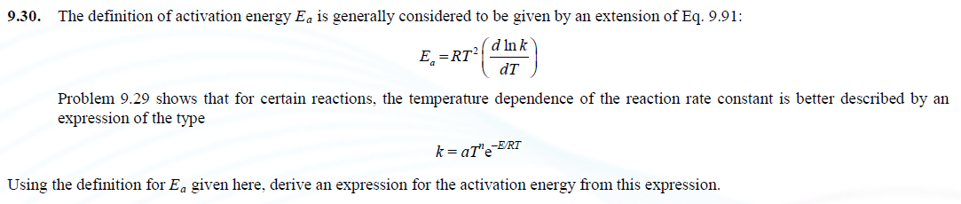
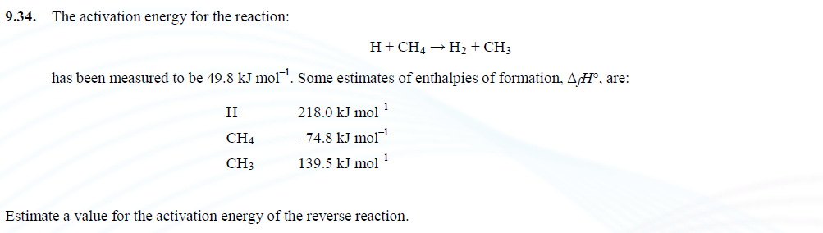
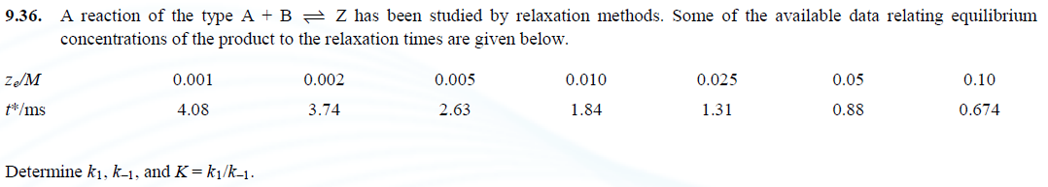

COLLISION THEORY AND TRANSITION-STATE THEORY

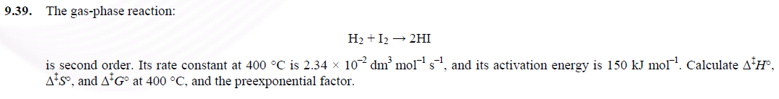
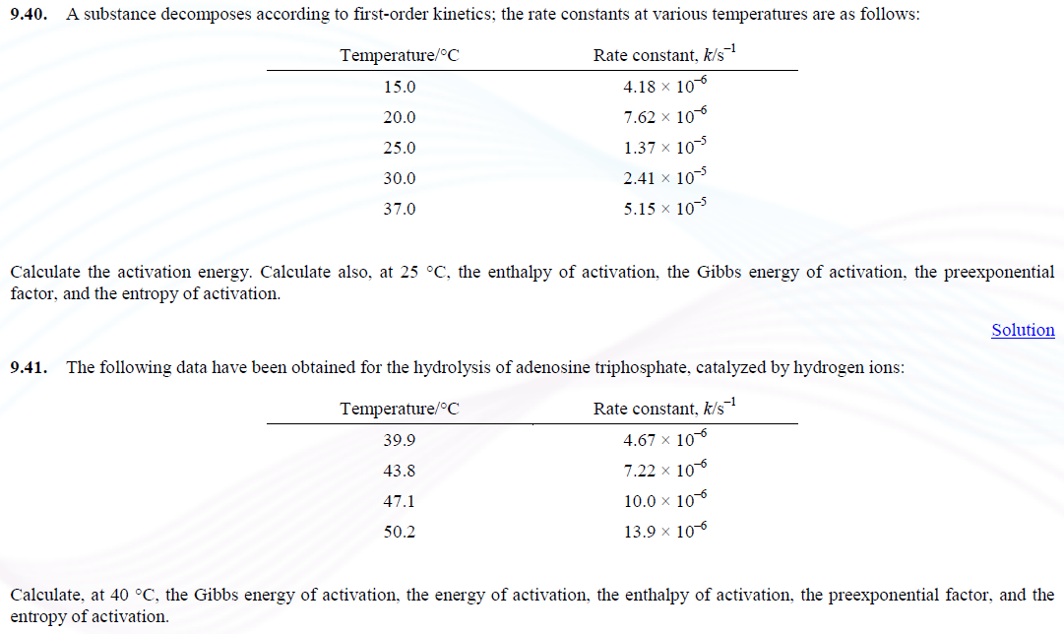
IONIC-STRENGTH EFFECTS
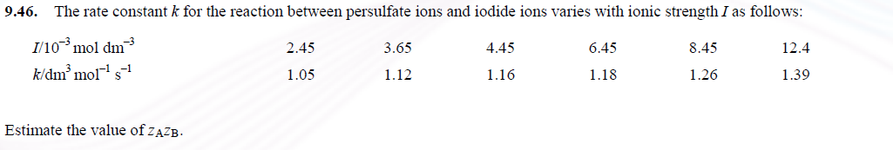
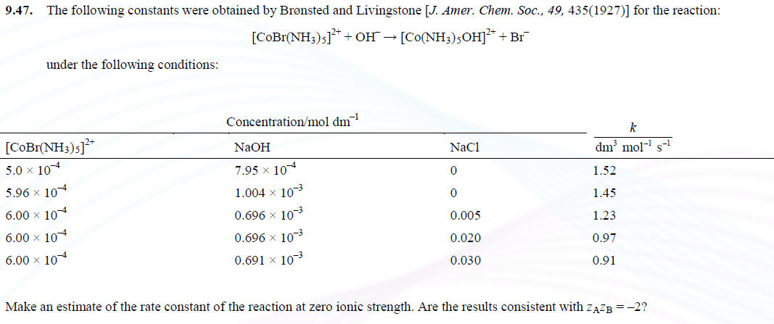
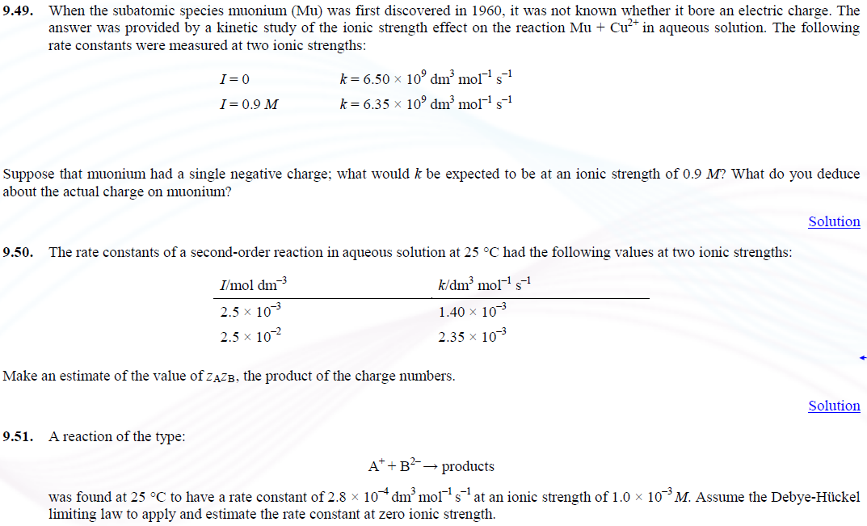
ESSAY QUESTIONS
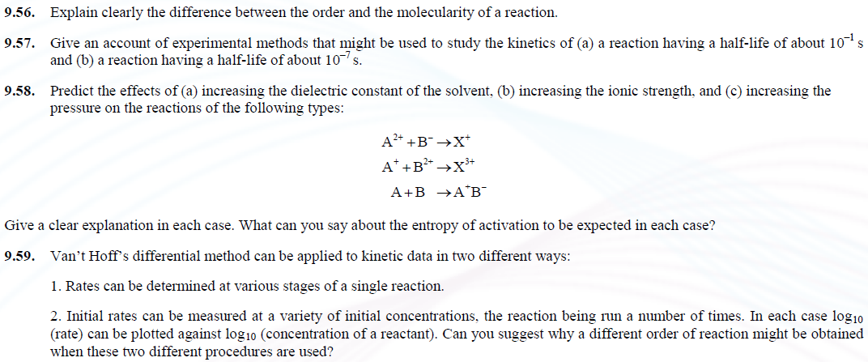
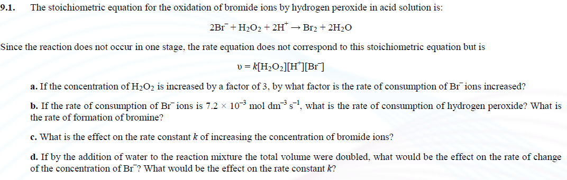

ELECTROCHEMICAL CELLS

ELECTRODE REACTIONS AND ELECTRODE POTENTIALS
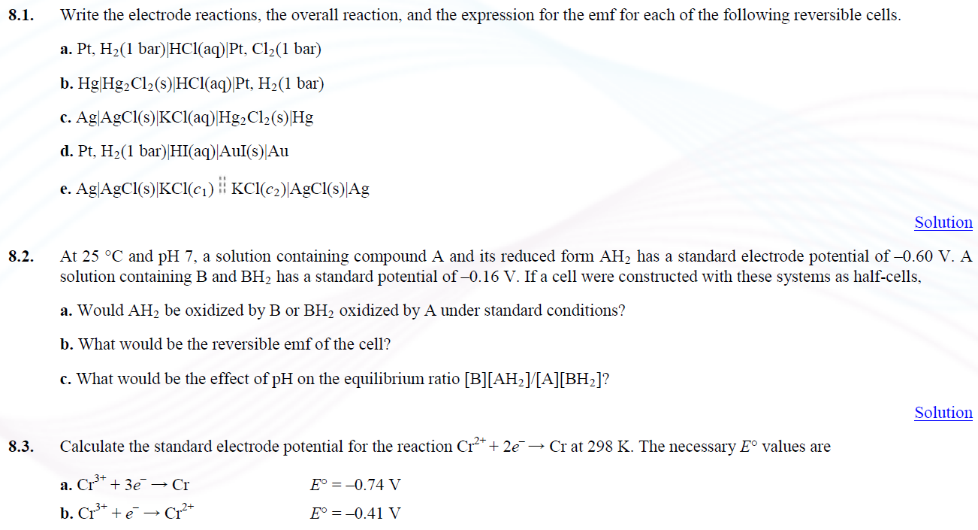
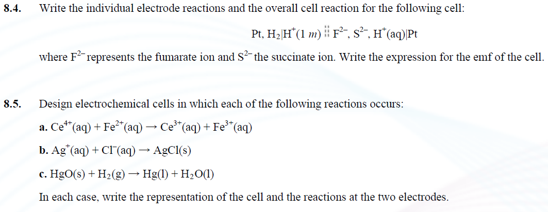

THERMODYNAMICS OF ELECTROCHEMICAL CELLS
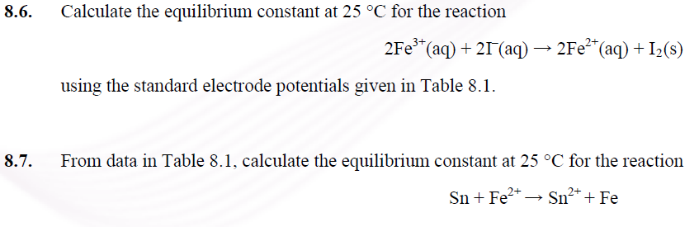
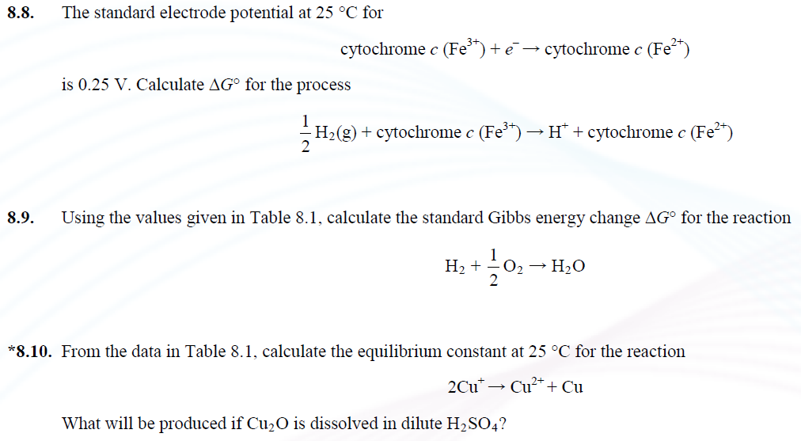

NERNST EQUATION AND NERNST POTENTIALS
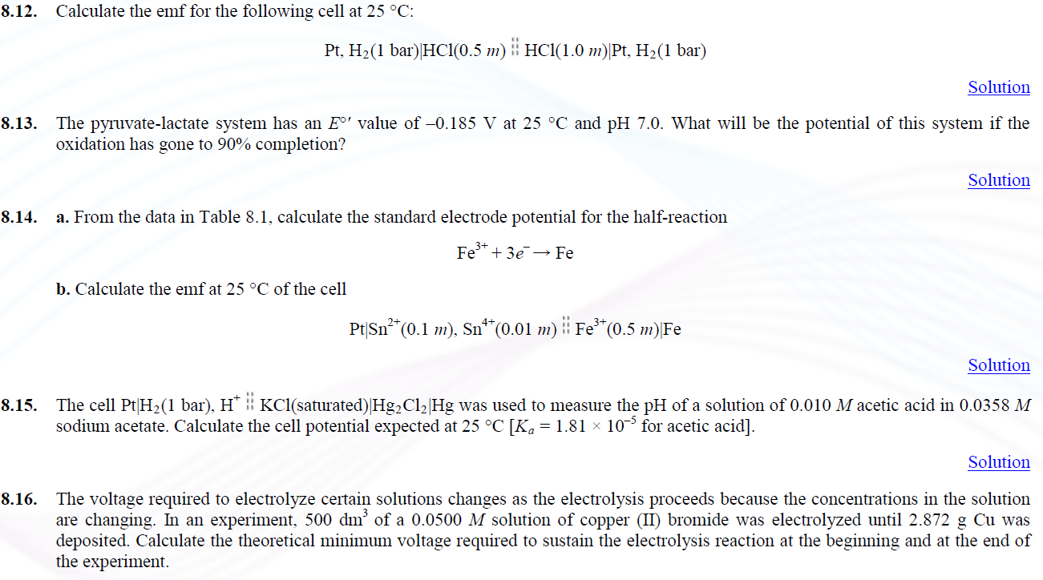
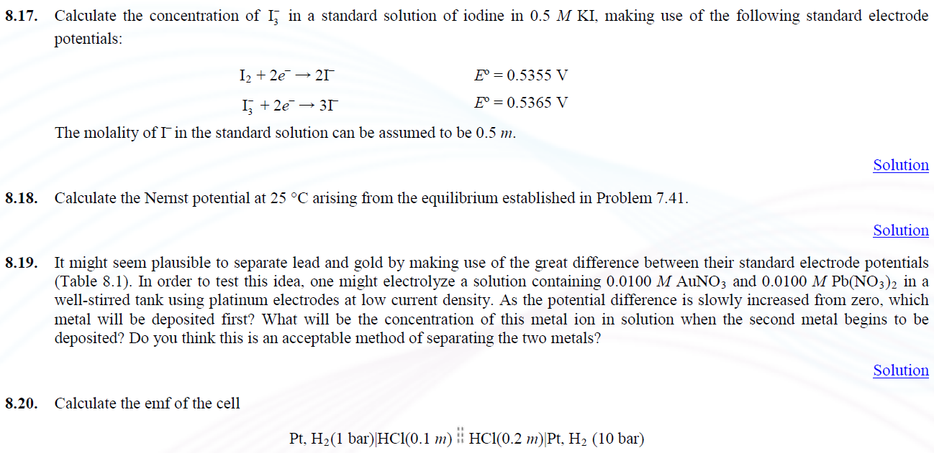

TEMPERATURE DEPENDENCE OF CELL EMFS
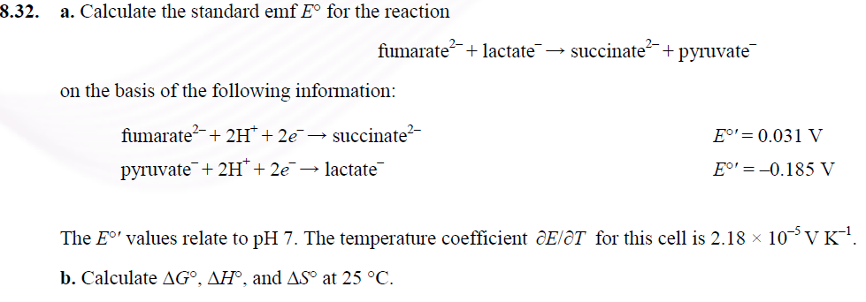
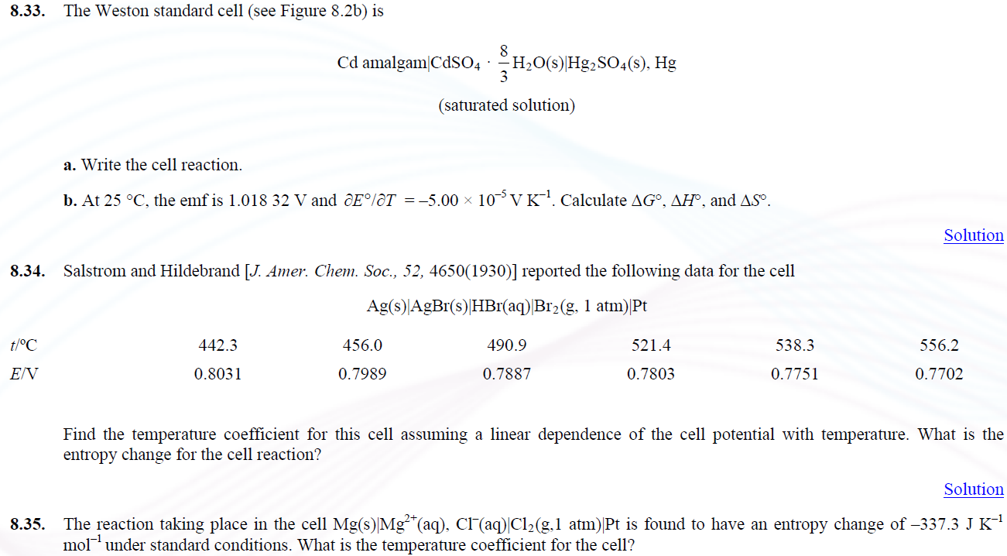

APPLICATIONS OF EMF MEASUREMENTS
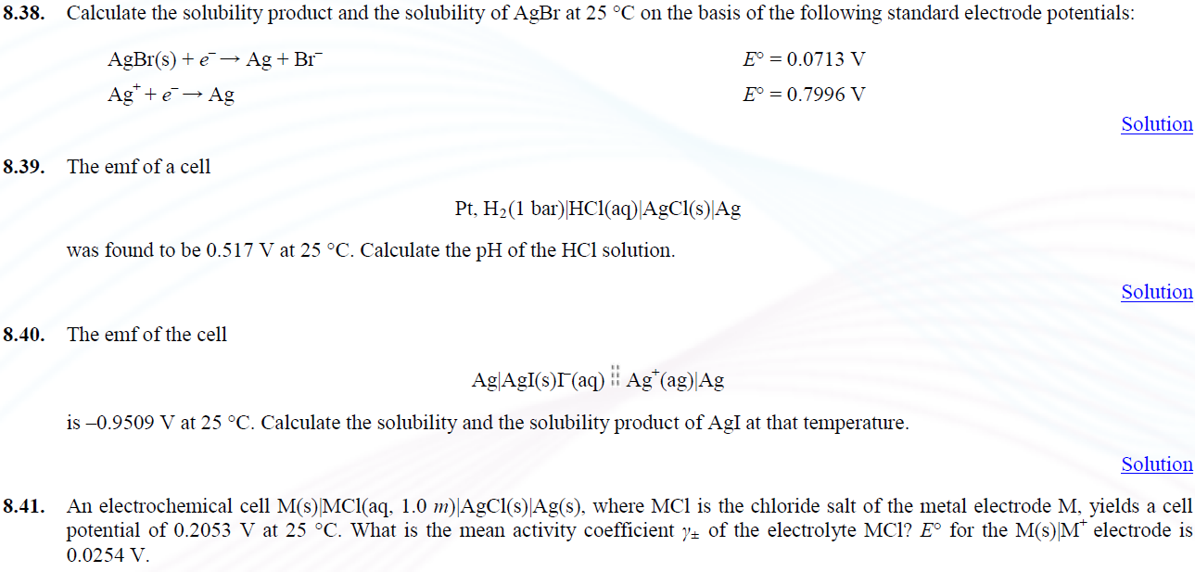
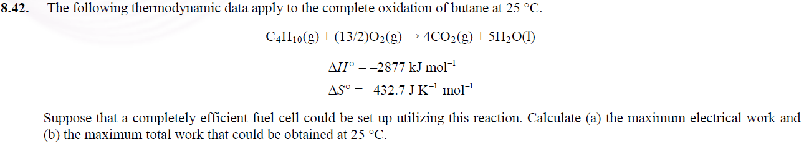

ESSAY QUESTIONS
